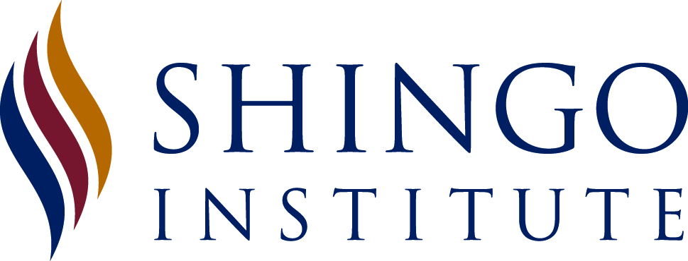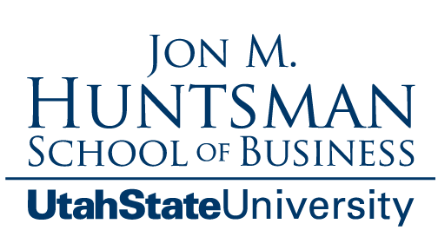

FOR IMMEDIATE RELEASE
CONTACT: Mary Price
Shingo Institute
Phone: +1.435.760.0711
Email: mary.price@usu.edu

The Lean Builder: A Builder’s Guide to Applying Lean Tools in the Field by Joe Donarumo and Keyan Zandy Receives Shingo Publication Award
Summary: After trained examiners and accomplished business professionals performed a thorough assessment of their work, Joe Donarumo and Keyan Zandy have been selected as recipients of an internationally recognized award from the Shingo Institute, a program in the Jon M. Huntsman School of Business. The authors will receive the award at the 33rd Annual Shingo Conference in Provo, Utah the week of May 17, 2021.
LOGAN, Utah — The Shingo Institute, a program in the Jon M. Huntsman School of Business at Utah State University, has awarded Joe Donarumo and Keyan Zandy with the Shingo Publication Award for their book, The Lean Builder: A Builder’s Guide to Applying Lean Tools in the Field. Donarumo is a senior superintendent at Linbeck Group, a Texas-based technology-driven Lean building construction firm. Zandy is the COO of Skiles Group, a national general contracting and Lean Construction management firm.
“Receipt of the Shingo Publication Award signifies an author’s significant contribution and practical application to the body of knowledge regarding enterprise excellence,” said Ken Snyder, executive director of the Shingo Institute.
By “challenging” or applying for a Shingo Publication award, authors invite a group of accomplished professionals and trained examiners from the Shingo Institute to thoroughly review their publication(s). Shingo examiners select recipients based on a rigorous set of standards.
Written for those who roll up their sleeves and do the work as craft professionals, foremen, and superintendents, The Lean Builder is a must-read for anyone new to Lean Construction, and certainly those professionals working in the field.
Cleverly written as a story with characters anyone in construction can relate to, The Lean Builder presents Lean processes, from pull planning and the Last Planner SystemTM, to Lean principles such as respect for people and continuous improvement. This book is easy to read and delivers these Lean concepts in a clear and understandable manner through practical scenarios within a construction project team. Any team, even those with individuals not very open to change and too comfortable with the status quo, would benefit from learning the Lean Construction practices and lessons so masterfully explored in The Lean Builder.
Dan Heinemeier, executive director of the Lean Construction Institute, said: “This is a book that should be read by anybody who sees Lean as too challenging to attempt, and even those who have tried it before and failed. It will correct misperceptions and inspire people to try something new.”
Authors Donarumo and Zandy will receive their award at the awards ceremony during the Shingo Conference in Provo, Utah, USA on May 17-21, 2021.The conference is a week-long event featuring a selection of workshops, plant tours, keynote speakers, and breakout sessions designed to provide ongoing knowledge, insights, and experience for organizations in pursuit of operational excellence. For more information regarding The Lean Builder or their online community centered around field-driven Lean tools and methodologies, please visit www.theleanbuilder.com.

About the Shingo Institute
The Shingo Institute is home of the Shingo Prize, an award that recognizes organizations that demonstrate an exceptional culture that fosters continuous improvement. Part of the Jon M. Huntsman School of Business at Utah State University, the Shingo Institute is named after Japanese industrial engineer and Toyota adviser, Shigeo Shingo. Dr. Shingo distinguished himself as one of the world’s thought leaders in concepts, management systems, and improvement techniques that have become known as the Toyota Production System.
Drawing from Dr. Shingo’s teachings and years of experience working with organizations worldwide, the Shingo Institute developed the Shingo Mode, which is the basis for its several educational offerings, including workshops, study tours, and conferences. Workshops are available in multiple languages through the Institute’s Licensed Affiliates. For more information on workshops, affiliates, or to register to attend the International Shingo Conference, please visit www.shingo.org and follow on LinkedIn or Twitter.
About The Lean Builder
To join the community and learn more, please visit http://www.theleanbuilder.com or follow on LinkedIn, Twitter or Instagram.

